CenturyLink Local Service Billing System Consolidation Plan

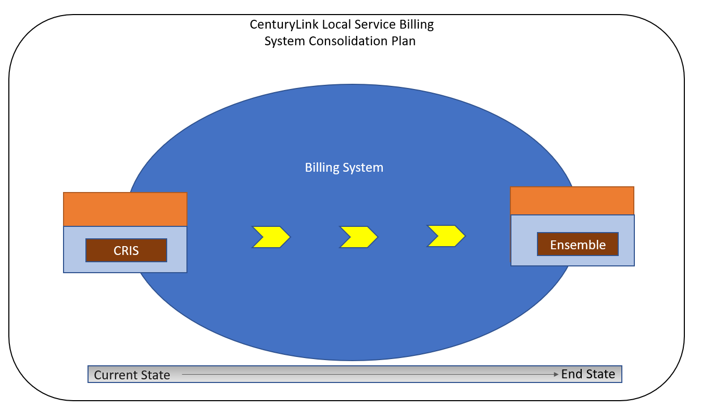

Document Modification Log

All revisions to this document are in chronological order.

Version | Date | Description of Change
1 | 1/8/24 | Update to timelines and misc clarifications
2 | 1/30/24 | Update to timelines

© 2016 CenturyLink, Inc., All Rights Reserved. The CenturyLink mark, pathways logo, and certain CenturyLink product names mentioned herein are the property of CenturyLink, Inc. All other marks are the property of their respective owners.

Contents
CenturyLink Local Service Billing System Consolidation Plan 1
1 Executive Summary 5
1.1 Scope 5
1.1.1.1 Items Not in Scope: 5
1.2 Assumptions 6
2 Ordering and Billing System Description 6
2.1 Current State System View 7
2.1.1.1 Service Delivery 7
2.1.1.2 Billing 7
2.1.1.3 Facility Based Directory Listing (FBDL) 8
2.1.1.4 Customer Ordering & Billing 8
2.2 End State System View 9
2.2.1 Transition to common processes and system infrastructure 9
2.2.2 Ensemble 9
2.2.3 Ordering 10
2.3 Billing End State System 10
2.3.1 Billing System Comparison Functionality – CRIS to Ensemble 10
2.3.2 Bill Format 10
2.3.3 Billing System Differences between CRIS to Ensemble 11
2.3.3.1 BANS 11
2.3.3.2 Bill Summary 11
2.3.3.3 RSID/ZCID 11
3 Consolidation Plan Implementation 12
3.1 Consolidation Plan Schedule and Milestones 12
3.1.1 Conversion Approach 12
3.1.2 Schedule and Milestones 12
3.2 3rd Party Facilitator 13
3.3 Consolidation Plan Implementation 13
3.3.1 Internal CenturyLink Consolidation Testing 14
3.3.2 Training and Process Plan 14
3.3.3 Customer Testing 14
3.3.4 Production Conversion Plan 14
3.3.5 Post Conversion Support 15
3.3.6 Contingency Plan 15
Appendix A: Ensemble Invoice & CSR Examples (Redacted) 16
Appendix B: Regulatory Organizations, Guidelines and Standards 17
Appendix C: Glossary 18
Appendix D: Document Authors 19

Executive Summary
CenturyLink is consolidating Local Service billing systems to streamline processes and systems across CenturyLink’s markets (hereafter, Consolidation). Due to Acquisitions (see Section 1.3), CenturyLink currently operates two different billing systems for Local Services. As a result, customers that are in multiple locations within CenturyLink’s network could be receiving bills from both systems making this inefficient for the customer and for CenturyLink.
During consolidation, CenturyLink will move all billing to Ensemble. (Refer to Section: 2: Ordering and Billing System Description for more information.) This consolidation will move properties off the Customer Records Information System (CRIS).
The benefits to the wholesale customers and CenturyLink of consolidating the billing systems across all CenturyLink Markets are to provide:
- Single process for Local Service Request billing functions
- Consistent billing levels – i.e. grouping of accounts across states
- Consistent method to view the billing for any products and services ordered on a Local Service Request
- Consistent bill format for all local billing
To reduce the risks associated with a conversion, the conversion will be implemented by bill periods.

Scope
The CenturyLink Local Service Billing System Consolidation Plan (hereafter; the Consolidation Plan) document provides CenturyLink’s wholesale customers, (hereafter; Customers) with further information about the Consolidation and how they will be affected.
The purpose of this document is to cover the scope of the Consolidation Plan to fulfill specific requirements of settlement agreements with various parties, as well as associated state commission and FCC orders, related to the CenturyLink/Qwest merger (hereafter, Merger Requirements). This document summarizes the critical milestones that will occur when CenturyLink consolidates the Current State Billing Systems into the End State solution. The Consolidation is planned for no earlier than May 2024

Items Not in Scope:
Items that are not in-scope for this project include, but are not limited to:
- System enhancements to EASE
- Access Service Request (ASR) processing

Assumptions
The following is a list of assumptions that are applicable during implementation and upon completion of the Consolidation:
- CenturyLink will comply with all applicable Merger Requirements
- CenturyLink will utilize the existing Qwest Corporation d/b/a CenturyLink Change Management Process (CMP) to communicate system and product/process changes in the appropriate timing and format for this conversion. To view the complete CMP document, visit the CMP Website or click on the Wholesale Change Management Process Document link
- The CMP timeline will be adjusted consistent with Merger Requirements
- Customers will continue to enter Local Service Requests in EASE and subsequently receive their bill output from Ensemble
- CenturyLink will communicate billing account number changes to Customers before the Consolidation
- Historical data for Bill/CSRs will be available for duplicate bill requests for 13 months
- CenturyLink will retain existing output choices for billing media (i.e., paper vs. electronic) at consolidation
- The Consolidation will support the remaining regulatory requirements for PID/PAP reporting

- As the project progresses, analysis and design activities may result in modifications to the consolidation plan

Ordering and Billing System Description
This section provides Customers with Current State and End State Ordering and Billing system views, common features, and information about the differences between Current State and End State systems. It also provides information about the functionality and applications that CenturyLink uses to facilitate Customer and system interfaces.

Current State System View

CenturyLink currently uses two separate Billing Systems. CenturyLink uses both CRIS and Ensemble for billing. The diagram below depicts the current state system view for Ordering and CRIS Billing.
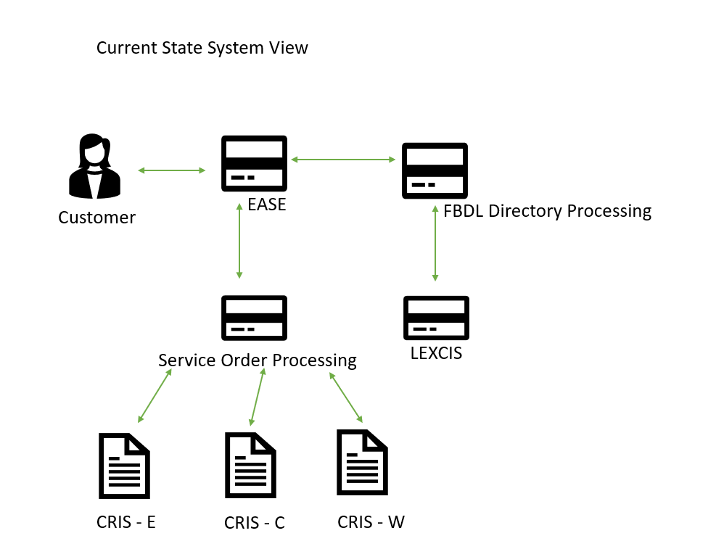

Service Delivery

EASE interfaces to an application called FTS, which constructs an order in one of three regionalized core-ordering applications, called Service Order Processors (SOPs). The SOPS create the Universal Service Order, used by the Telcordia suite of provisioning systems to establish service.

Billing

The Service Order (S.O.) is transmitted from the Service Order Processor to the 3 CRIS regions for billing today.

Facility Based Directory Listing (FBDL)

Directory Listings are sent from IMA to the Qwest Directory Builder application, which creates and stores the directory listing based on Local Service Request Directory requests.
Directory Listings are billed in the LEXCIS billing system.

Customer Ordering & Billing

Century Link currently requires, based on end user location, the use of multiple billing platforms with different media and invoice formats.

The graphic above illustrates the wholesale process and billing local service today.

End State System View

Transition to common processes and system infrastructure

The following diagram depicts the End State Ordering and Billing System for all CenturyLink Markets.
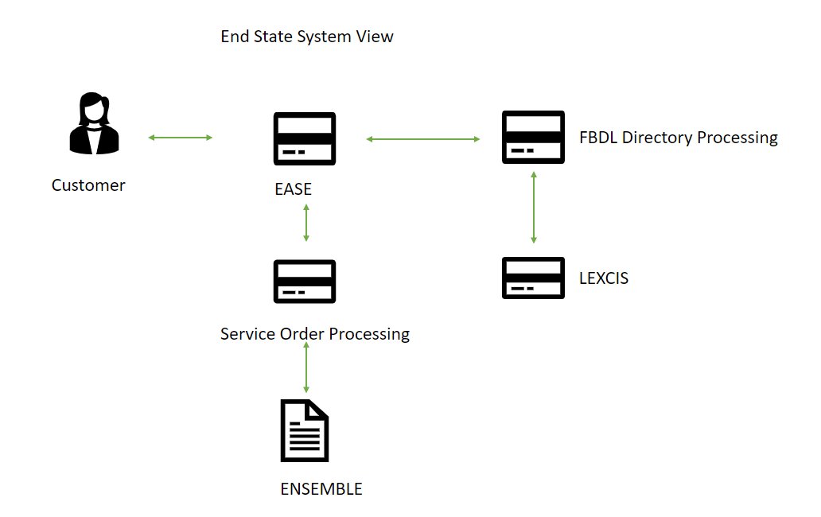

Ensemble
Ensemble is the end state system that bills customers for services ordered through Local Service Requests. EASE will continue to utilize a Service Order Processor for provisioning the service. Once completed, Billing records in Ensemble are created. Ensemble also supports the directory listing fulfillment and billing processes.
Ensemble is the billing system application that is used to set up new customer accounts, facilitate billing services, set up Directory Listings, view customer information and many other customer-related services.

Ordering

Order Functionality | EASE
Create and submit a request | Yes*

EASE will continue to order via USOC’s as is done today. The virtual CSR will show as price plans/features.

*Indicates some development may be required prior to CLEC Testing

Billing End State System

CenturyLink uses Ensemble to bill services ordered through a Local Service Request.
Ensemble was developed by AMDOCS. AMDOCS is an industry leading billing and OSS platform provider. Many telecom providers, including AT&T, Sprint, T-Mobile and Bell Canada, use their software. AMDOCS has been in business for over 30 years and specializes in Software and Services for communications, media and entertainment industry service providers worldwide. They are particularly well known for their revenue management products.
AMDOCS is a publicly traded company (NASDAQ: DOX) with annual revenue for the fiscal year 2022 of approximately $4.58B.
The Ensemble application is a full-service ordering and billing suite currently supporting the legacy CenturyLink retail and wholesale customer base. The Ensemble application is fully integrated into legacy CenturyLink’s accounting, regulatory reporting and service delivery platforms.

Billing System Comparison Functionality – CRIS to Ensemble

Bill Format
Ensemble uses Price Plans and Feature codes for billing where CRIS uses USOCs (Universal Service Order Codes). The bill provides a Current Charges Summary section that lists Monthly, One-time and Usage charges. Where applicable, Department totals and a Department Summary by sub-department is presented. The Charge Detail section identifies charges (monthly and one-time charges) by Product-ID. Local Usage detail is provided when applicable. Lastly, an account summary page is presented.
The following table shows key capabilities of the System.
CRIS to Ensemble Billing System Integration
Key Capabilities | Description
Online Bill View | CenturyLink will provide the Customer with an external link for up to 13 months of bill invoices. The Customer will be able to sign up for this access. This history will be built going forward after Consolidation.  The current tool is My Account and will be moving to Control Center.
Media Options | Ensemble provides multiple options for receiving bills. Options include paper, online bill viewing, and EDI standard files.
Invoices | CenturyLink will continue to provide industry compliant invoices. Refer to separate attachment for Appendix A: Ensemble Invoice & CSR Examples.

Note: Technical, legal and regulatory changes may affect the information provided in the above table. The table above does not reflect changes made following the introduction of this document in CMP.

Billing System Differences between CRIS to Ensemble

BANS
Ensemble uses a nine-digit account number (i.e. 123456789), whereas CRIS uses a TN number format for the Billing Account Number (BAN). CenturyLink will provide the BAN conversion information prior to consolidation.

Bill Summary
Account, department, and sub-department summaries are available in the bill.

RSID/ZCID
Values from CRIS will NOT be carried over to Ensemble.

Note: Technical Specifications will explain any electronic billing file differences, if applicable.

Consolidation Plan Implementation
The Consolidation Plan provides a framework for informing all participants about the Consolidation.

Consolidation Plan Schedule and Milestones

Conversion Approach

The overall conversion will be accomplished in phases, corresponding to the customer’s bill cycles. This document will be updated once the cycle to phase alignment is available.

Schedule and Milestones

Consolidation will begin by 5/20/2024 and will be complete by 6/30/2024. CenturyLink will comply with all applicable Merger Requirements, including use of the CMP process.

The following table shows a list of milestones that impact the Consolidation Plan. CenturyLink will communicate updated milestone dates per the CMP process.
= A milestone, established by the Merger Requirements, that alters the established CMP milestones schedule.

Consolidation Plan Milestone | Due By for Items
CMP CR Issuance: SCR041923-1, SCR041923-3  These can be found at: http://www.centurylink.com/wholesale/cmp/cr/crnumber_system_index.html | 4/19/2023
CR Presentation at CMP Meeting | 5/17/2023
Local Service Request Consolidation Plan due | 6/19/2023
Initial Release Notification for SCR041923-1 | 6/19/2023
Initial Retirement Notice for SCR041923-3 | 6/19/2023
Local Service Request Consolidation Plan Review Meeting | 7/12/2023
Extended Customer Comment Window for Initial Release Notification, Initial Retirement Notice and Consolidation Plan | 7/27/2023
CenturyLink issues response to CLEC comments and Final Retirement Notice, including the Final version of the Local Service Request Consolidation Plan | 8/21/2023
3rd Party Facilitator Selected | 8/18/2023
Draft Interface Tech Specs | 9/22/2023
Tech Specs Walk-through | 10/3/2023
CLEC Comments for Interface Tech Specs | 10/9/2023
Final Interface Tech Specs | 10/13/2023
L&P Volume Testing | 11/20/2023
(New) GUI Initial Release notice | 12/7/2023
(New) GUI Draft Release notes | 12/22/2023
Product Process Notification associated with Level 2 OSS changes | 12/22/2023
CLEC comments due on (New) GUI Release Notes | 12/25/2023
CLEC comments due on Level 2 OSS Product Process changes | 12/29/2023
Training available | 12/29/2023
GUI Final Release Notice | 12/29/2023
Final Notice For Level 2 OSS Product/Process Changes | 1/5/2024
Customer Testing Begins with Local Service Request Consolidation Functionality (120 Days) | 2/1/2024  2/8/2024
Customer Testing Ends | 5/31/2024  6/7/2024
Customer Go/No Go Vote | 6/3/2024  6/10/2024
Release to Production (by bill period)
Conversion By Cycle 1 | 6/5/2024  6/12/2024
Conversion By Cycle 2 | 6/12/2024  6/19/2024
Conversion By Cycle 3 | 6/19/2024  6/25/2024

3rd Party Facilitator
In accordance with the Merger Requirements, CenturyLink will contract with a 3rd Party Facilitator to coordinate between companies during planning and execution of Customer Testing. Refer to Section 3.3.3: Customer Testing.
The 3rd Party Facilitator will be engaged in 3Q2023. The CLECS will have the opportunity for input on the 3rd Party Facilitator requirements. The Facilitator will assist in Customer Testing scenario development and be available during the 120-day Customer Testing period which begins in 1Q2024.

Consolidation Plan Implementation
This section provides further details on the Consolidation Plan implementation, including testing, training, conversion plan, and contingency planning.

Internal CenturyLink Consolidation Testing
CenturyLink will execute test Local Service Requests through EASE to ensure that proper billing codes assignation occurs and the Local Service Requests flow successfully into Ensemble for billing. CenturyLink business SMEs (Subject Matter Experts) will check for accuracy and completeness.
The following is the standard process that CenturyLink has used for previous consolidations and will use for this system consolidation:
- First, internal testing consisting of ‘mock’ conversions from CRIS into Ensemble prior to the Customer testing period will be iteratively executed.
- Test bills will be generated and compared to production Ensemble bills for accuracy.
Automated comparisons will occur for all circuits/products that are on the account, all monthly recurring charges, taxes, and any in-flight activity such as pending payments, one-time charges and disputes. CenturyLink resources will investigate fallout and issues during the comparison process and update the processes/programs to achieve billing accuracy.
CenturyLink SMEs from EASE and CRIS/Ensemble systems and process areas will participate in testing and validation efforts. In addition, contract resources will supplement these internal resources to ensure intense focus on Consolidation activity and to allow 24-hour cycles.

Training and Process Plan
Per the Merger Agreement, CenturyLink will provide Customer training and education without charge.
For the Consolidation, CenturyLink will provide the following:
- CenturyLink will conduct a Customer walk through session prior to the start of Customer testing
- An additional Customer walk-through of the training will be conducted before Consolidation
- CenturyLink will provide updated external documentation prior to the beginning of the Customer testing phase

Customer Testing
In accordance with the Merger Agreement, CenturyLink will make available a testing environment at the appropriate time for the Customers to test Local Service Requests into the EASE ordering system. A testing schedule will allow the generation of test bills and CSRs at scheduled intervals during the 120-day testing window. Before testing begins, the process to log and track defects will be communicated.

Production Conversion Plan

The overall Consolidation for billing will be implemented with a pilot followed by three conversions. These conversions will be flash cuts of the CRIS application that is in use for that customer prior to the conversion. The customers bill cycle will play a role in the cut to ensure billing is not underway during the conversion. The Ensemble application will then be in use for that customer post-conversion. The Consolidation will be coordinated with the customer.

Customers’ will receive notifications of the Consolidation’s maintenance window. There will be a live bridge open at CenturyLink with key CenturyLink resources that will be available to immediately investigate and address any concerns once the production systems are back online. Customers will receive issue ticket logging and escalations processes prior to the Consolidation weekend. At Consolidation, all existing products billed in CRIS will convert and all new bills will be generated from Ensemble for the impacted region.

Post Conversion Support
Post conversion support staff will be available to assist key operational functions including ordering centers, care functions, provisioning operation centers and billing teams with any post-conversion issues. The support team will include program, IT and functional SMEs. Internal status meetings will be conducted regularly to monitor progress. Customers will be supported by their normal operations centers. CenturyLink will ensure its staffing and training plans will accommodate post conversion support needs.

Contingency Plan

At the beginning of the maintenance window the account will be flagged in CRIS as in Embargo, to block any activities. The accounts will be extracted and sent to Ensemble for loading. Once the account is loaded, the account will be removed from CRIS.
In the event of an issue during conversion. The account impacted will be backed out of Ensemble and the Embargo flag will be removed from CRIS, putting the account back in normal service in CRIS all during the planned maintenance window.
- Ensemble Invoice & CSR Examples (Redacted)

CRIS Redacted Resale Bill:
Ensemble Redacted Resale Bill:

- Regulatory Organizations, Guidelines and Standards
The following is a list of regulatory organizations, guidelines and industry standards mentioned in this document.
- CMP (CenturyLink Change Management Process)
  - http://www.centurylink.com/wholesale/cmp/review.html
- FCC (Federal Communications Commission)
  - www.fcc.gov/
- PUC (Public Utility Commissions)
  - The following link is to the National Association of Regulatory Utility Commissioners. You will be able to obtain information about Public Utilities Commissions by State
http://www.naruc.org/Commissions/

- Glossary
The glossary lists terms and acronyms used in this document with descriptions and definitions.
Term/Acronym | Description/Definition
BAN | Billing Account Number
CLEC | Competitive Local Exchange Carrier
CMP | Change Management Process
CRIS | Customer Records and Information System
CSR | Customer Service Records
Current State System View | Denotes CenturyLink’s existing systems and their functionality pre-Consolidation
EASE | Electronic Administration & Service Order Exchange
End State System View | Denotes CenturyLink’s systems and functionality post Consolidation
FBDL | Facility Based Directory Listing
FCC | Federal Communications Commission (USA)
LEXCIS | Local Exchange Carrier Invoice System
LSR | Local Service Request
OSS | Operating Service System
PUC | Public Utility Commissions
S.O. | Service Order
USOC | Universal Service Order Code

- Document Authors
The table below lists the qualifications of the document authors including information technology professionals with substantial experience and knowledge regarding CenturyLink systems, process, and requirements.

Title | Years of Telco Experience | Service in CenturyLink | Service in Qwest | Role in Preparation of Consolidation Plan
Business Analyst | 2 | 0 | 0 | Business Analyst
SR Manager Software Engineering | 34 | 9 | 11 | Robotics Process Automation
Dir. Sales Enablement | 15 | 12 | 5 | Customer portal assurance
Sr Process Analyst | 28 | 4 | 28 | SD Wholesale Order Entry Process Support
SR TECHNICAL PROCESS ARCHITECT | 18 | 9 | 9 | Support
Lead Billing Analyst | 23 | 9 | 14 | statement production and distribution
Lead Product Manager Portal | 28 | 28 |  | Control Center
Principal Architect | 43 | 2 | 2 | system architect
Sr Process Analyst | 44 | 10 | 34 | Wholesale Compliance, PID/PAP, ICA, Contractual, Regulatory Reporting & Metrics
Business Analyst | 10 | 3 | 0 | Business Analyst on Project
Manager Reporting & Metrics | 25 | 9 | 14 | Reporting & metrics
SR Manager Software Engineering | 34 | 34 | 11 | Manager of Robotics Process Automation team
SR MGR Service Delivery | 45 | 10 | 35 | Process Mapping and Order Entry
Sr Lead Solution Architect | 28 |  | 18 | Solutioning
Manager Billing | 25 | 25 | 5 | Billing Support
Sr Project Manager, Enterprise CFS | 25 | 7 | 0 | Project Manager help with back-end systems
Software Development Manager | 16 | 12 | 4 | BOS BDT formatting
Government Operations Director | 42 | 10 | 32 | Wholesale Compliance, PID/PAP, ICA, Contractual, Regulatory Reporting & Metrics
Sr. Billing Analyst | 25 | 9 | 12 | Reporting & metrics
Sr Technical Architect | 34 | 9 | 25 | Support
Lead Project Manager | 22 | 1 | 0 | Project Lead of the C2E migration
Enterprise Architect | 36 | 10 | 10 | Consulting to the Project
Delivery Project Executive - Luman | 24 | 24 | 0 | Lead Technical Project Manager
Technical Process Architect II | 43 | 9 | 34 | Support
MGR Process Improvement | 43 | 9 | 34 | Support
Lead Software Engineer | 22 | 22 | 0 | Ensemble Billing/Bill Formatter
Lead Analyst - Regulatory Support | 38 | 38 | 13 | Advocate for CLECs, field questions, contract implementation & compliance, CMP issues
Delivery Manager | 20 | 7 | 0 | Delivery of Execution
Sr Finance Analyst | 23 | 23 |  | Discount mapping.

See In the Matter of the Joint Petition for Approval of Indirect Transfer of Control of Qwest Operating Companies to CenturyLink, Minnesota Public Utilities Commission, Docket No. p-421, et al./PA-10-456, Settlement Agreement between the Joint Petitioners and Joint CLECs, March 4, 2011.

